**JAVA AND MAVEN INSTALLATION IN JENKINS**

**Manage Jenkins:** To access and configure Jenkins environment.

**Global tool configuration:** We can define tools that Jenkins will use for its builds, such as Maven, JDK, Git, Gradle, or custom tools.

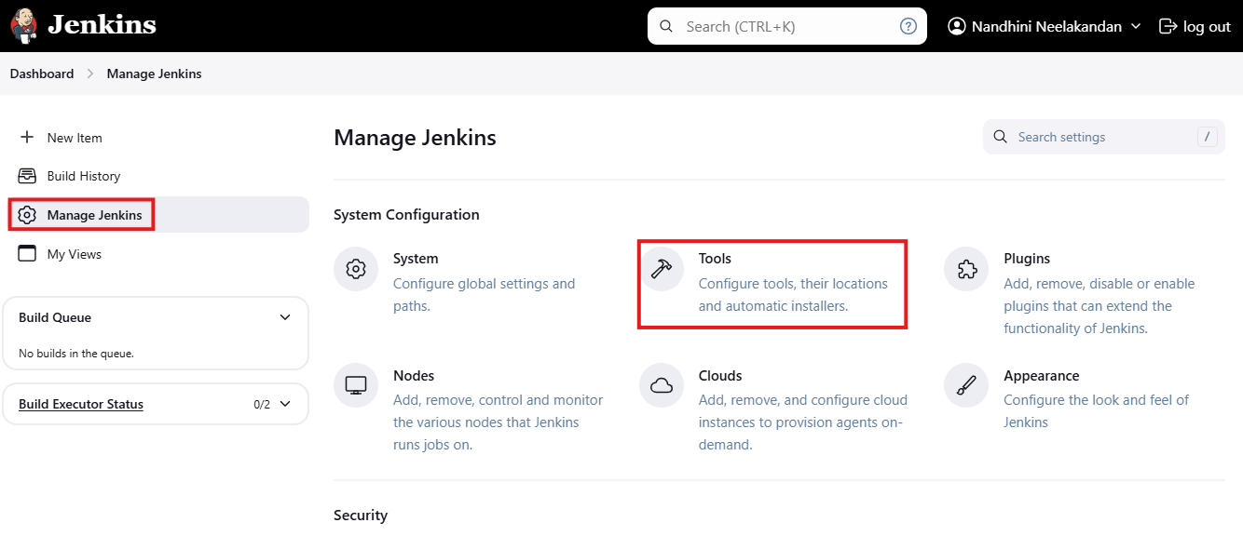

Check for **Java and Maven versions** in the local server, before creating projects in Jenkins.

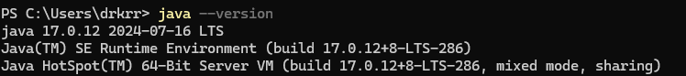

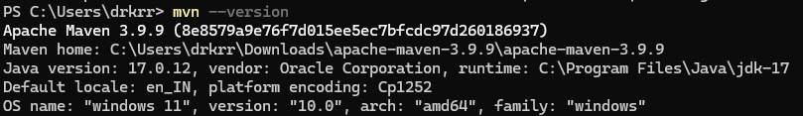

Create a new item using a Freestyle project (A flexible project that can build any software project and is often used for simple setups).

Customized the view of the dashboard by removing a few unwanted filters. **(My_View).**

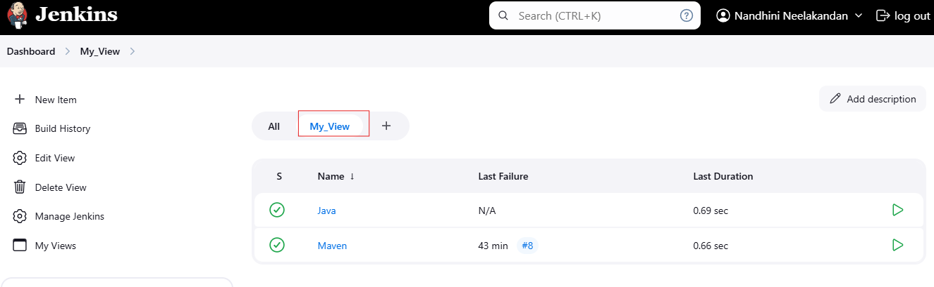

**JAVA INSTALLATION:**

**Step 1:** To configure Java, provide the name and path of the Java installation directory. (Consider the same path used for JAVA_HOME.)

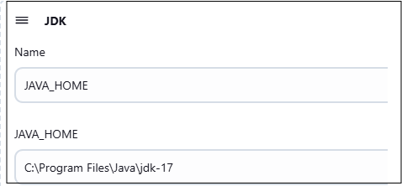

**Step 2:** Create a new project (Java) and Specify build actions (Execute Windows batch command).

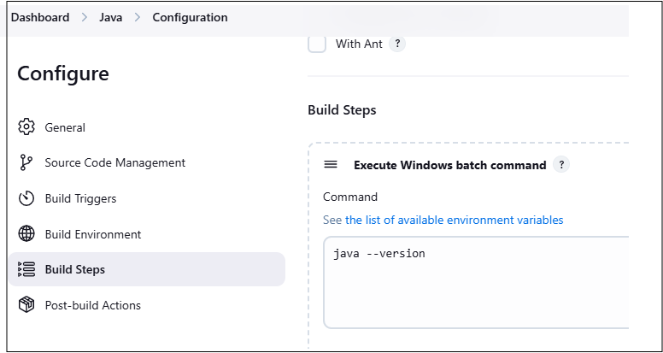

**Step 3:** Check for an Output by clicking **Build Now.**

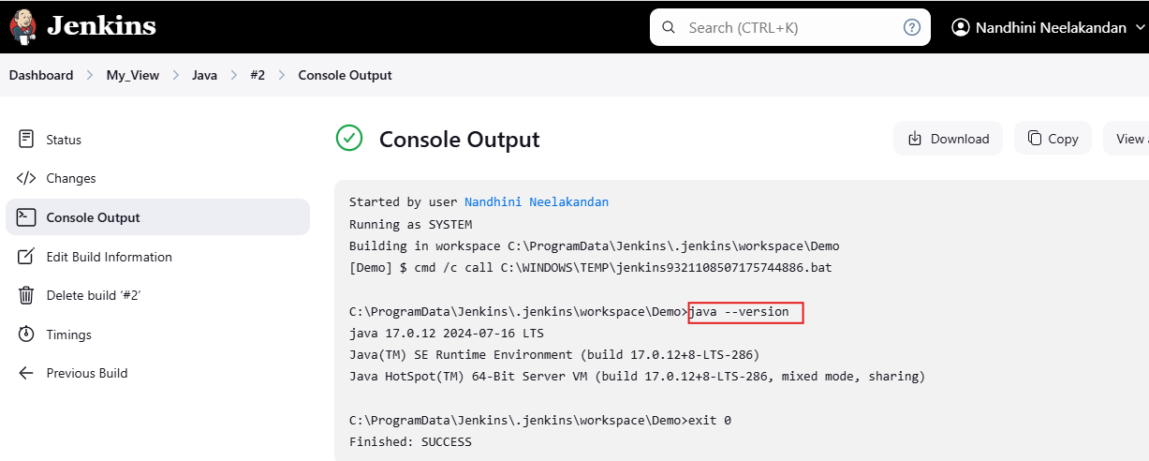

**MAVEN INSTALLATION:**

**Step1:** To configure Maven is to provide a name and path of the maven installation directory. (Consider the same path used for MAVEN_HOME).

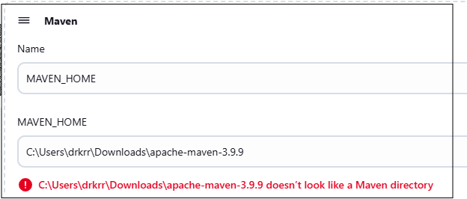

**Step 2:** Create a new project (Maven) and Specify build actions (Execute Windows batch command).

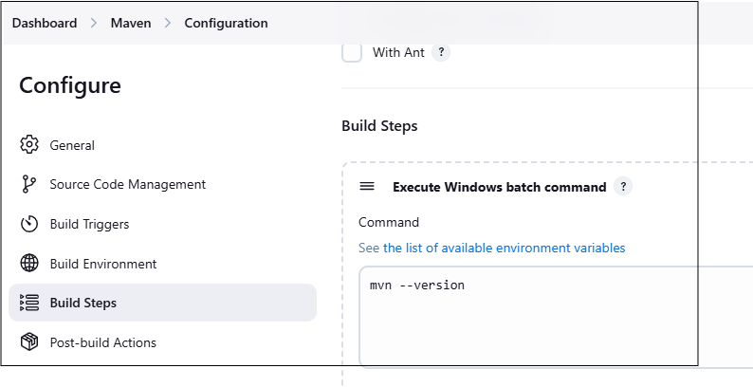

**Step 3:** Check for an Output by clicking Build Now.

